**Test Scenarios**

Test Scenario: Registration at the Login Page(test_registration.py)

|  |  |  |  |  |  |
| --- | --- | --- | --- | --- | --- |
| Test Scenario | Test Description | Test Values | Expected Outcome | Actual Outcome | Justification |
| 1 | To test the “Registration” button link at Login page for verify it able to direct new user to Sign up page | Go to Click “Login” on the navigation bar.  Or  Click “Login” on the navigation bar.  Click on the “Registration” button link | Direct to <http://localhost:8000/accounts/signup/>  Display title “Sign up”  Display:  Input textbox for Username  Input textbox for Password  Input textbox for Password Confirmation  “Sign up” button | Direct to <http://localhost:8000/accounts/signup/>  Display title “Sign up”  Display:  Input textbox for Username  Display warnings for Username   * Display for username: “Required. 150 characters or fewer. Letters, digits and @/./+/_”   Display:  Input textbox for Password  Display warnings for password:   * Your password can't be too similar to your other personal information. * Your password must contain at least 8 characters. * Your password can't be a commonly used password. * Your password can't be entirely numeric.   Input textbox for Password Confirmation  Display for warnings for Password Confirmation:   * Enter the same password as before, for verification.   “Sign up” button |  |
| 2 | User sign up with 151 character in username | Username: “ttttttttttttttt ttttttttttttttt ttttttttttttttt ttttttttttttttt ttttttttttttttt ttttttttttttttt ttttttttttttttt ttttttttttttttt ttttttttttttttt tttttttttttttttt”  Password: passwordtest123  Confirmation password: passwordtest123 | Remain on the same page “<http://localhost:8000/accounts/signup/>” and display tab remains “Sign Up”  Displays pop up warnings for username: “Enter a valid username. This value may contain only letters, numbers, and @/./+/-/_ characters.” | Remain on the same page “<http://localhost:8000/accounts/signup/>” and display tab remains “Sign Up”  Displays pop up warnings for username: “Enter a valid username. This value may contain only letters, numbers, and @/./+/-/_ characters.” |  |
| 3 | User sign up with empty username, empty password and empty password confirmation | Username: “”  Password: “”  Password confirmation: “” | Remain on the same page “<http://localhost:8000/accounts/signup/>” and display tab remains “Sign Up”  Username input displays required error: “Please fill up this field”.  Password and Password confirmation field did not display anything | Remain on the same page “<http://localhost:8000/accounts/signup/>” and display tab remains “Sign Up”  Username input displays required error: “Please fill up this field”.  Password and Password confirmation field did not display anything | Because no inputs for both username name, password, confirmation password  Validation of username checks that there is no username input. |
| 4 | To test user, sign up with their username contains up to 150 letters with invalid symbols | Username: “Themotherofmilkywaycontainsprecious9pizzasareMercury,Venus,Earth,Mars,Jupiter,Saturn,Uranus, NeptuneandPluto.\!@#$^&*&*(^.^)*%$#@?/”  Password: passwordtest123  Confirmation Password: passwordtest123 | Remain on the same page “<http://localhost:8000/accounts/signup/>” and display tab remains “Sign Up”  Displays pop up warnings for username: “Enter a valid username. This value may contain only letters, numbers, and @/./+/-/_ characters.” | Remain on the same page “<http://localhost:8000/accounts/signup/>” and display tab remains “Sign Up”  Displays pop up warnings for username: “Enter a valid username. This value may contain only letters, numbers, and @/./+/-/_ characters.” | Username is not allowed for letters with symbols. |
| 5 | To test user, sign up with empty username | Username: “”  Password: passwordtest123  Confirmation Password:  Paswordtest123 | Remain on the same page “<http://localhost:8000/accounts/signup/>” and display tab remains “Sign Up”  Displays pop up warnings for username: “Please fill in this field” | Remain on the same page “<http://localhost:8000/accounts/signup/>” and display tab remains “Sign Up”  Displays pop up warnings for username: “Please fill in this field” |  |
| 6 | To test user, sign up their username with fewer symbols and set password with more than 8 characters | Username: @/.+-_test  Password: passwordtest123  Confirmation Password: passwordtest123 | Remain on the same page “<http://localhost:8000/accounts/signup/>” and display tab remains “Sign Up”  Displays pop up warnings for username: “Enter a valid username. This value may contain only letters, numbers, and @/./+/-/_ characters.” | Remain on the same page “<http://localhost:8000/accounts/signup/>” and display tab remains “Sign Up”  Displays pop up warnings for username: “Enter a valid username. This value may contain only letters, numbers, and @/./+/-/_ characters.” | Username is not allowed to have symbols. |
| 7 | To test user, sign up their user name with char but password only numbers | Username: testing12345  Password:  12345678  Confirm Password:  12345678 | Remain on the same page “<http://localhost:8000/accounts/signup/>” and display tab remains “Sign Up”  Display pop up warnings for password: “This password is entirely numeric” and “This password is too common.” | Remain on the same page “<http://localhost:8000/accounts/signup/>” and display tab remains “Sign Up”  Display pop up warnings for password: “This password is entirely numeric” and “This password is too common.” |  |
| 8 | To test user sign up their username with only numbers | Username: “123123123”  Password: “passwordtest123”  Confirmation password “passwordtest123” | Redirect to <http://localhost:8000/accounts/login/>  Display title “Login”  Display:  Input textbox for Username  Input textbox for Password  “Login” button  Display “Don't have an account yet? Register here!”  Display “Register” link button | Redirect to <http://localhost:8000/accounts/login/>  Display title “Login”  Display:  Input textbox for Username  Input textbox for Password  “Login” button  Display “Don't have an account yet? Register here!”  Display “Register” link button |  |
| 9 | To test existing the user sign up with the same username he registered previously but in different password | Username: “testing12345789”  Password: “passwordtest123”  Confirmation password “passwordtest123” | Remain on the same page “<http://localhost:8000/accounts/signup/>” and display tab remains “Sign Up”  Displays pop up warnings for username: “A user with that username already exists.” | Remain on the same page “<http://localhost:8000/accounts/signup/>” and display tab remains “Sign Up”  Displays pop up warnings for username: “A user with that username already exists.” | Username must be different. |
| 10 | To test the user register with password that user set is different from the confirmation password | Username: “tester1”  Password: “passwordtest123”  Confirmation password: “password123” | Remain on the same page “<http://localhost:8000/accounts/signup/>” and display tab remains “Sign Up”  Displays pop up warnings for username: “The two password fields didn't match.” | Remain on the same page “<http://localhost:8000/accounts/signup/>” and display tab remains “Sign Up”  Displays pop up warnings for username: “The two password fields didn't match.” | Validation checks that the password and confirmation password not matched. |
| 11 | To test the user sign up with valid username in letters with symbols and set password with more than 8 characters with numeric | Username: [finer@.@8](mailto:finer@.@8)  Password: passwordtest123  Confirmation password: passwordtest123 | Redirect to <http://localhost:8000/accounts/login/>  Display title “Login”  Display:  Input textbox for Username  Input textbox for Password  “Login” button  Display “Don't have an account yet? Register here!”  Display “Register” link button | Redirect to <http://localhost:8000/accounts/login/>  Display title “Login”  Display:  Input textbox for Username  Input textbox for Password  “Login” button  Display “Don't have an account yet? Register here!”  Display “Register” link button |  |
| 12 | Test user sign up with empty passwords | Username: [test12345678](mailto:finer@.@8)  Password: “”  Confirmation password: “” | Remain on the same page “<http://localhost:8000/accounts/signup/>” and display tab remains “Sign Up”  Display pop up warning for password input displays required error: “Please fill up this field”. | Remain on the same page “<http://localhost:8000/accounts/signup/>” and display tab remains “Sign Up”  Display pop up warning for password input displays required error: “Please fill up this field”. |  |
| 13 | Test user sign up with password length less than 8 | Username: Tester2  Password: test123  Confirmation password: test123 | Remain on the same page “<http://localhost:8000/accounts/signup/>” and display tab remains “Sign Up”  Display pop up warnings: “The password is too similar to the username.  This password is too short. It must contain at least 8 characters.  This password is too common.” | Remain on the same page “<http://localhost:8000/accounts/signup/>” and display tab remains “Sign Up”  Display pop up warnings: “The password is too similar to the username.  This password is too short. It must contain at least 8 characters.  This password is too common.” |  |
| 14 | Test user sign up with password that is common | Username: Tester3  Password: password  Confirmation password: password | Remain on the same page “<http://localhost:8000/accounts/signup/>” and display tab remains “Sign Up”  Display pop up warnings: “This password is too common. | Remain on the same page “<http://localhost:8000/accounts/signup/>” and display tab remains “Sign Up”  Display pop up warnings: “This password is too common. |  |
| 15 | Test user sign up but confirmation password is empty | Username: tester1  Password: passwordtest123  Confirmation password: “” | Remain on the same page “<http://localhost:8000/accounts/signup/>” and display tab remains “Sign Up”  Display popup warning for password input displays required error: “Please fill up this field”. | Remain on the same page “<http://localhost:8000/accounts/signup/>” and display tab remains “Sign Up”  Display popup warning for password input displays required error: “Please fill up this field”. |  |
| 16 | Test user sign up with valid information | Username: testing123456789  Password: passwordtest123  Confirmation password: passwordtest123 | Redirect to <http://localhost:8000/accounts/login/>  Display title “Login”  Display:  Input textbox for Username  Input textbox for Password  “Login” button  Display “Don't have an account yet? Register here!”  Display “Register” link button | Redirect to <http://localhost:8000/accounts/login/>  Display title “Login”  Display:  Input textbox for Username  Input textbox for Password  “Login” button  Display “Don't have an account yet? Register here!”  Display “Register” link button |  |



Test Scenario: Login page(test_login.py)

|  |  |  |  |  |  |
| --- | --- | --- | --- | --- | --- |
| Test Scenario | Test Description | Test Values | Expected Outcome | Actual Outcome | Justification |
| 1 | To test the navigation link to the login page. | Click “Login” on the navigation bar. | Display title “Login”  Display:  Input textbox for Username  Input textbox for Password  “Login” button  Display “Don't have an account yet? Register here!”  Display “Register” link button | Display title “Login”  Display:  Input textbox for Username  Input textbox for Password  “Login” button  Display “Don't have an account yet? Register here!”  Display “Register” link button | - |
| 2 | User log in with empty username and password | Username: “” Password: “” | Remain on the same page “<http://127.0.0.1:8000/accounts/login/>” and display tab remains “Login”  Username input displays required error: “Please fill up this field”.  Password field did not display anything | Remain on the same page “<http://127.0.0.1:8000/accounts/login/>” | Because no inputs for both username name and password  Validation of username checks that there is no username input. |
| 3 | User log in with wrong username and empty password | Username “peter”    Password: “” | Password input displays required error: “Please fill up this field”. | Remain on the same page “<http://127.0.0.1:8000/accounts/login/>” | Validation of password checks that there is no password input. |
| 4 | User log in with right password and empty username | Username: “”  Password: passwordtest123 | Username input displays required error: “Please fill up this field”.    Password field did not display anything | Remain on the same page “<http://127.0.0.1:8000/accounts/login/>” | Validation of username checks that there is no username input. |
| 5 | User logs in with right username and wrong password | Username: finer    Password: %&$*# | Remain on the same page. “<http://127.0.0.1:8000/accounts/login/>”  Error displays: “Please enter a correct username and password. Note that both fields may be case-sensitive.” | Remain on the same page “<http://127.0.0.1:8000/accounts/login/>”  Error displays:  “Please enter a correct username and password. Note that both fields may be case-sensitive.” | The validation check that the password is incorrect and consider the current username entered by the user is incorrect and did not match username and password of Super user. |
| 6 | To test when the user logs in with wrong username and password | Username: %^&*()%$#@#& *&*&$_+++++&&&&?????/ #*    Password: %%%%% | Remain on the same page “<http://127.0.0.1:8000/accounts/login/>”    Error displays: “Please enter a correct username and password. Note that both fields may be case-sensitive.” | Remain on the same page “<http://127.0.0.1:8000/accounts/login/>”  Error displays: “Please enter a correct username and password. Note that both fields may be case-sensitive.” | The validation checks current username and its password entered by the current user did not matches with the username and password of a Super user. |
| 7 | User logs in with the right username and right password | Super User:    Username: finer  Password: passwordtest123 | Redirects to  <http://localhost:8000/> | Redirects to  <http://localhost:8000/>  Display:  “Welcome back finer! Want to play a game?”  Display:  “logout” link button  “reset password” link button  “Todo List” link button | Note*  Register or sign up before login |
|  |  |  |  |  |  |

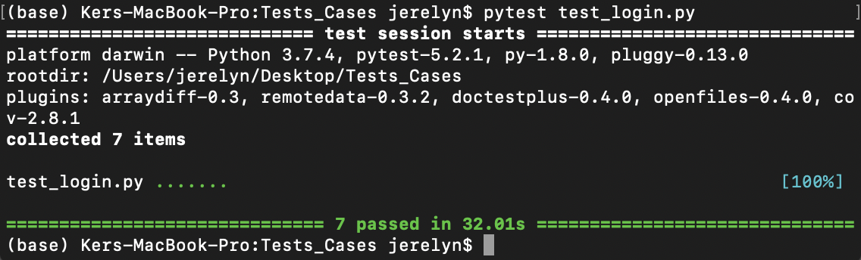

Test Scenario: Adding and Deleting in todo page(test_todo.py)

|  |  |  |  |  |  |
| --- | --- | --- | --- | --- | --- |
| Test Scenario | Test Description | Test  Values | Expected Outcome | Actual Outcome | Justification |
| 1 | To test the feature of Todo navigation button at the navigation bar for able to navigate to display the todo page, input textbox and add button | Click on “To Do” navigation button | Navigate directly to  <http://localhost:8000/todo/> | The font for Todo’s navigation button at the navigation bar becomes white colour  Navigate directly to  <http://localhost:8000/todo/> Display page title: “Todo” and “View all your current and active todo items.” Display input textbox and add button | - |
| 2 | To test clicking on the “Add” button without entering any texts in the input textbox | Click “Add” button | Displays a pop up “Unable to add!” | Remain on the same page  <http://localhost:8000/todo/> Display page title: “Todo” and “View all your current and active todo items.” On top of the todo textbox with its “Add” button, it displays a bullet point and a “Delete” button | [Fail]:  Validation not set! |
| 3 | To test clicking on the “Add” button with input text entered in the input textbox | Textbox: Play Final Fantasy XIII  Click “Add” button | “Play Final Fantasy XIII” is added. | Remain on the same page  <http://localhost:8000/todo/> Display page title: “Todo” and “View all your current and active todo items.” On top of the todo textbox with its “Add” button, it displays a bullet point with “Play Final Fantasy XIII” and a “Delete” button | - |
| 4 | To test clicking on the “Add” button with symbols entered in the input textbox | Textbox: ~`!@#$%^&*()_+}{“:<>?|\  Click “Add” button | “~`!@#$%^&*()_+}{“:<>?|\” is added. | Remain on the same page  <http://localhost:8000/todo/> Display page title: “Todo” and “View all your current and active todo items.” On top of the todo textbox with its “Add” button, it displays a bullet point with “~`!@#$%^&*()_+}{“:<>?|\” and a “Delete” button | - |
| 5 | To test clicking on the “Add” button with input texts, spacing, numbers and symbols entered into the input textbox | Textbox: Hang out with friends! 8^.^8  Click “Add” button | “Hang out with friends! 8^.^8” is added. | Remain on the same page  <http://localhost:8000/todo/> Display page title: “Todo” and “View all your current and active todo items.” On top of the todo textbox with its “Add” button, it displays a bullet point with “Hang out with friends! 8^.^8” and a “Delete” button | - |
| 6 | To test clicking the delete button for to remove those already added into the todo page | Click “Delete” button. | Texts with bullet points added previously into the todo page are successfully removed and all delete buttons are disappeared  Remain on the same page <http://localhost:8000/todo/>  Display an empty input textbox and “Add” button | All texts with bullet points added previously into the todo page are successfully removed and all delete buttons are disappeared.  Remain on the same page <http://localhost:8000/todo/> | - |

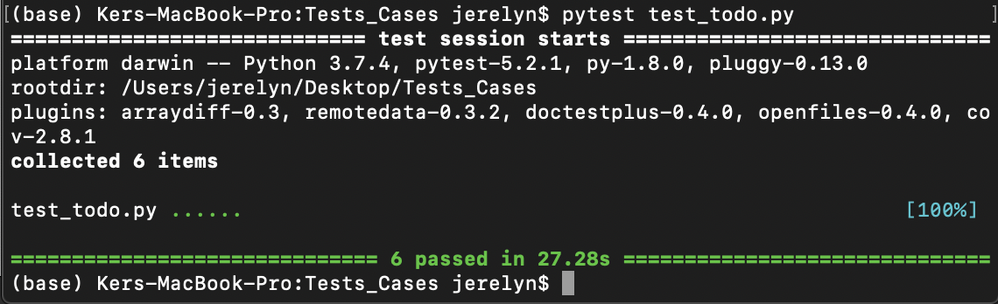

Test Scenario: Todo History page (test_todo_history.py)

|  |  |  |  |  |
| --- | --- | --- | --- | --- |
| Test Scenario | Test Description | Test Values | Expected Outcome | Actual Outcome |
| 1 | To test the feature of Todo History’s navigation button for able to display the Todo History such as viewing what the user have added / deleted previously | Click on “Todo History” navigation button to display the todo list added(existing)  /deleted by user “finer” | Display title “Todo History” and display “View all todo items from anyone”  Display information of user:  Content  DateTime  Author  Status | The font for Todo History’s navigation button at the navigation bar becomes white colour  Display direct to “<http://localhost:8000/todo/history/>” page  Todo History navigation button is highlighted in white colour.  Display title “Todo History” and display “View all todo items from anyone.”  Display:  A screenshot of a cell phone  Description automatically generated |

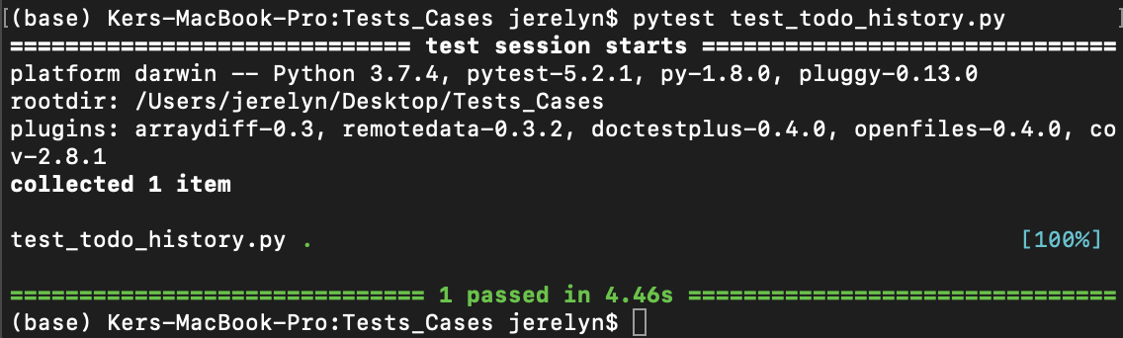

Test Scenario: Team Contribution page(test_todo_history.py)

|  |  |  |  |  |
| --- | --- | --- | --- | --- |
| Test Scenario | Test Description | Test Values | Expected Outcome | Actual Outcome |
| 1 | To test the feature of Team Contribution’s navigation button able display each member’s name and the description of their job roles | Click on “Team Contribution” navigation button | Display  “Project Manager + (Developer & QA Member)”  Display  “Ker Ning Hui”  Display “Ning Hui was assigned the role of a Project Manager, along with being a developer and a QA member. Although she is the overall manager of this project, she was still required to carry out her duties as a developer and a QA member. As a developer, she was assigned the role of working on and coding out the Team Contributions page as instructed by the technical lead, while providing assistance to other developers. As a QA member, she was assigned to work on the selenium and pytest codes and testing alongside the QA lead. Finally, as a project manager, she was required to monitor the issues and step in whenever necessary. She oversees the overall project movement and actions of her team members while giving certain instructions to the QA lead and technical lead when the need arises and to keep the project moving.”  Display “QA Lead”  Display “  Koh Fang Ting”  Display “Fang Ting was assigned the role of a QA lead where she leads her QA members. In this team however, there is only one other QA member. Therefore, not only is she required to work on the testing just like a QA member, she also had to lead the other QA member in the team and provide clear instructions and tasks for that member to work on. She came up with the test cases and monitors the commits by the developers so that she can make changes to her test cases while raising issues whenever there are bugs found in the codes. She had to constantly update her test cases due to the frequent changes to the codes and ensured that her test cases matches with the most current codes.”  Display “Technical Lead”  Display “  Lee Ze Rong”  Display “Ze Rong was assigned the role of a technical lead whereby he was in charge of the developers in this team. In addition to managing the developers under him, he was also required to carry out his duties as a developer. He was tasked to work on the To Do History page as well as helping out for the To Do page as one of the team's developer could not make his codes work. He also constantly monitors the activities of his development team's progress through github commits and manages the merging of the branches to the master branch to ensure that there are no conflicts before allowing a push request into it. This ensures that the website works as intended before having the QA carry out tests on it.”  Display “Developer”  Display “  Jansen Ros”  Display “Jansen was assigned the role of a developer whereby he was required to code out certain parts of the project. He was given the task of developing the To Do page but was unable to get his codes working, which resulted in having some features of the page done by the team's technical lead instead. Despite the inability to produce a functioning page, effort was still made to the best of his abilities. Therefore, the To Do page was completed due to the collaboration between Jansen and the technical lead.”  Display “Developer”  Display “  Ray Tan”  Display “Ray was also assigned the role of a developer and was required to code out certain parts of the project. At the start of the project, he was required to work on coding out a simple code base (referencing from the video) which will later serve as the core to be further developed on. He was later on assigned to also work on the User Login page. Despite having a working page, there were many conflicts between the master branch and his own branch which resulted in the need for the technical lead to step in and make changes to ensure they can merge without any issues. Assistance from one other developer in the team was also requested.” | The font for Team Contribution’s navigation button at the navigation bar becomes white colour.  Display direct to <http://localhost:8000/teamContributions/>  Display “Team Contribution” (display in bigger header size, bold)  Display  “Project Manager + (Developer & QA Member)” (display in header size, bold)  Display  “Ker Ning Hui” (display in smaller header size, bold)  Display “Ning Hui was assigned the role of a Project Manager, along with being a developer and a QA member. Although she is the overall manager of this project, she was still required to carry out her duties as a developer and a QA member. As a developer, she was assigned the role of working on and coding out the Team Contributions page as instructed by the technical lead, while providing assistance to other developers. As a QA member, she was assigned to work on the selenium and pytest codes and testing alongside the QA lead. Finally, as a project manager, she was required to monitor the issues and step in whenever necessary. She oversees the overall project movement and actions of her team members while giving certain instructions to the QA lead and technical lead when the need arises and to keep the project moving.”  (Display in paragraph format, without bold)  Display “QA Lead” (display in header size, bold)    Display  “Koh Fang Ting” (display in smaller header size, bold)  Display “Fang Ting was assigned the role of a QA lead where she leads her QA members. In this team however, there is only one other QA member. Therefore, not only is she required to work on the testing just like a QA member, she also had to lead the other QA member in the team and provide clear instructions and tasks for that member to work on. She came up with the test cases and monitors the commits by the developers so that she can make changes to her test cases while raising issues whenever there are bugs found in the codes. She had to constantly update her test cases due to the frequent changes to the codes and ensured that her test cases matches with the most current codes.”  (Display in paragraph format, without bold)  Display “Technical Lead” (display in header size, bold)  Display “  Lee Ze Rong” (display in smaller header size, bold)  Display “Ze Rong was assigned the role of a technical lead whereby he was in charge of the developers in this team. In addition to managing the developers under him, he was also required to carry out his duties as a developer. He was tasked to work on the To Do History page as well as helping out for the To Do page as one of the team's developer could not make his codes work. He also constantly monitors the activities of his development team's progress through github commits and manages the merging of the branches to the master branch to ensure that there are no conflicts before allowing a push request into it. This ensures that the website works as intended before having the QA carry out tests on it.”  (Display in paragraph format, without bold)  Display “Developer” (display in header size, bold)  Display “  Jansen Ros” (display in smaller header size, bold)  Display “Jansen was assigned the role of a developer whereby he was required to code out certain parts of the project. He was given the task of developing the To Do page but was unable to get his codes working, which resulted in having some features of the page done by the team's technical lead instead. Despite the inability to produce a functioning page, effort was still made to the best of his abilities. Therefore, the To Do page was completed due to the collaboration between Jansen and the technical lead.”  (Display in paragraph format, without bold)  Display “Developer” (display in header size, bold)  Display “  Ray Tan” (display in smaller header size, bold)  Display “Ray was also assigned the role of a developer and was required to code out certain parts of the project. At the start of the project, he was required to work on coding out a simple code base (referencing from the video) which will later serve as the core to be further developed on. He was later on assigned to also work on the User Login page. Despite having a working page, there were many conflicts between the master branch and his own branch which resulted in the need for the technical lead to step in and make changes to ensure they can merge without any issues. Assistance from one other developer in the team was also requested.”  (Display in paragraph format, without bold) |

